Error 1

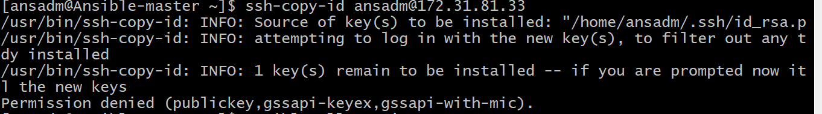

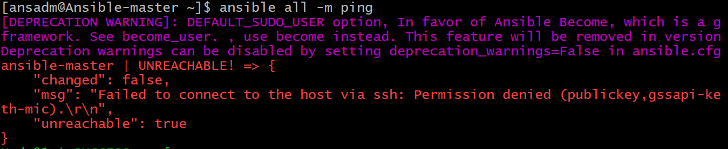

Ans: enable **“PasswordAuthentication yes”**

**Cmd: vi /etc/ssh/sshd-config**

**Then copy ssh key**

**Cmd: ssh-copy-id <username>@<ip/hostname>**

**Exa: ssh-copy-id** [**ansadm@172.31.81.33**](mailto:ansadm@172.31.81.33)

**2.**  **"Could not find or access ' while unarchive**

**even: file is exist with full permission**



Ans: add **remote_src** attribute in **unarchive** module.

Exa:

